# 1.0 Objectives

In this lab you will construct and test a simple digital circuit on a breadboard. Specifically, you will connect three TTL microchips to implement a 2-to-1 multiplexer (or MUX for short). Figure 1 shows the logical diagram for this circuit, which computes the following Boolean expression:

$f=\underline{s}x_{1}+{sx}_{2}$

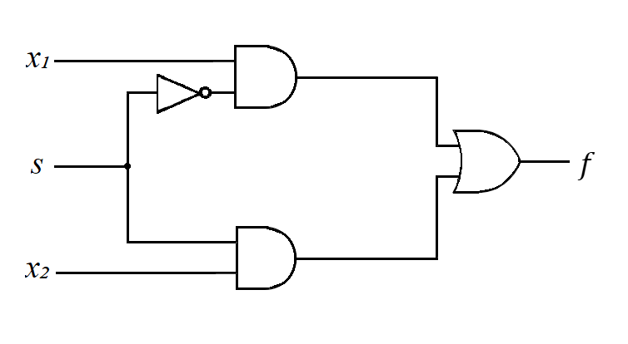Figure 1: Logic diagram for a 2-to-1 MUX.

# 2.0 Parts List

| **Quantity** | **Item** | |
| --- | --- | --- |
| 1 | White 830-point Breadboard | |
| Set of | Breadboard Wire Spools | Or, you could use a Pre-Cut Wire Kit |
| 1 | Wire Cutters Electronic Grade |
| 1 | Wire Strippers Electronic Grade |
| 1 | [CD74HC08E](https://www.ti.com/lit/ds/symlink/cd74hc08.pdf) Chip (Four AND gates) | |
| 1 | [CD74HC32E](https://www.ti.com/lit/ds/symlink/cd74hct32.pdf) Chip (Four OR gates) | |
| 1 | [CD74HC04E](https://www.ti.com/lit/ds/symlink/cd74hc04.pdf) Chip (Six NOT gates) | |
| 1 | 4-Position DIP switch SPST (e.g, [5435640-2](https://www.digikey.com/en/products/detail/te-connectivity-alcoswitch-switches/5435640-2/969224) or [BPA04B](https://www.digikey.com/en/products/detail/c-k/BPA04B/949993)) | |
| 1 | 5mm Red LED | |
| 4 | 1 kΩ THT Resistor | |
| 1 | Breadboard Power Supply (e.g, [YwRobot MB-V2](https://static.rapidonline.com/pdf/73-4538_v1.pdf)) | |

# 3.0 Background

## 3**.1** 2-to-1 MUX

Figure 2 repurposes a figure from your digital logic textbook to show one possible wiring that implements the MUX with TTL chips. Compare this circuit to the logic diagram in Figure 1 and verify that they compute the same Boolean function.

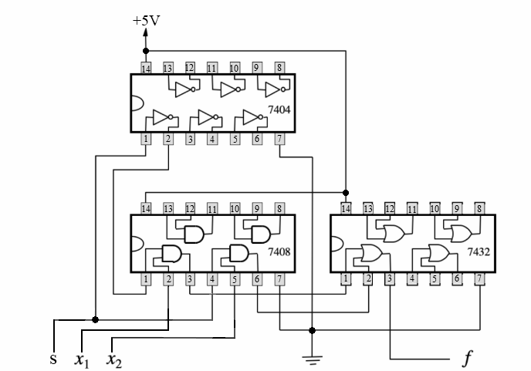

Figure 2: TTL microchip implementation of the 2-to-1 MUX ( $f=\underline{s}x_{1}+{sx}_{2}$).

The three TTL microchips are: 7404, 7408 and 7432. Each of these chips is an integrated circuit that contains multiple copies of one logic gate. Chip 7404 contains 6 NOT gates, 7408 contains 4 AND gates, and 7432 contains 4 OR gates. When wired together, these chips can be used to implement complex circuits. It’s important to note that each of these chips has a Vcc pin(5V or 3.3V) in the upper-left corner (in this figure) and a GND pin (ground) in the lower-right corner to provide power.

## 

## 3.2 Human Interface

The circuit has three inputs ($s$, $x_{1}$, and $x_{2}$) and one output ($f$). The inputs will be mapped to a set of switches. The output will be visualized with an LED (light emitting diode). Figure 3 shows this mapping, which uses one resistor for each line. These resistors are necessary for the proper operation of the circuit. Figure 4 shows the components of an LED. Note that the two legs of the LED do not have the same length. The positive end is the longer one (also called the anode). The negative end is shorter (also called the cathode).

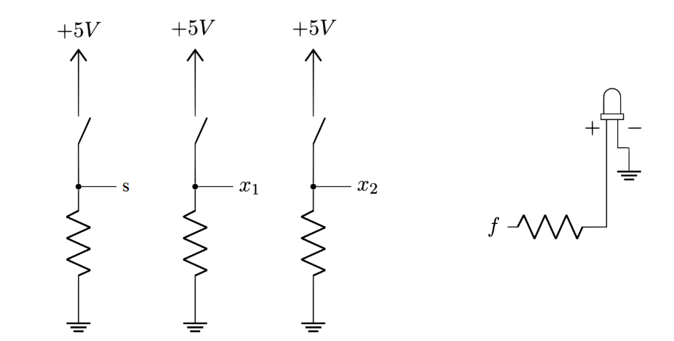

Figure 3: Electrical diagram for the three inputs and the output.

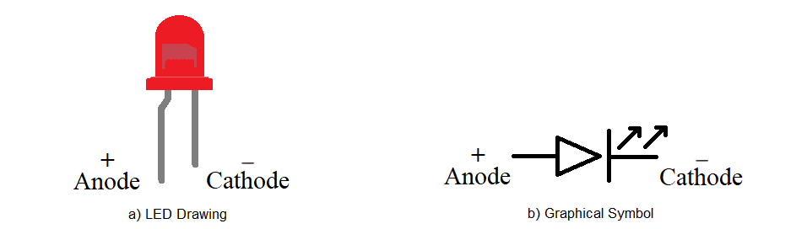

Figure 4: Diagram of an LED and its corresponding graphical symbol.

## 3.3 The Breadboard

The breadboard contains a field of pins that can be used to connect circuit components. There are two sets of power rails: two positive and two negative. The positive rails are marked in red and also have a plus sign. The negative rails are black and have a minus sign. The pins on each positive rail are connected horizontally as shown in the bottom part of Figure 5. The same is true for the pins on each negative rail. All other pins of the breadboard are connected in vertical groups of five pins as shown in the figure below. There are two sets of these groups, one on each side of the central notch.





Figure 5: Front and back view of a breadboard.

# 

# 

# 4.0 Activity

Before starting the activity please complete the pre-lab, which will help you understand the circuit that you need to construct. As a part of standardization, ensure that your breadboard is rotated properly: the positive voltage rail should be at the top and the ground rail at the bottom. In addition, each chip has a semicircular cutout on one of the sides. Ensure that this semicircle is facing to the left when your breadboard is properly oriented. In this orientation, pin 1 will always be in the lower-left corner of the chip (indicated with a white circle in Figure 6).

## 4.1 Place Chips, Switches, Power and Ground

Place the chips on the breadboard such that the pins straddle the central notch. Exact placement (left or right) does not matter, but to follow along with this activity you should place them in the following order: DIP switches, 7404 (NOT), 7408 (AND), and finally 7432 (OR). Be sure to leave enough space on the right end of the breadboard for the power supply.

Connect all chips to power and ground. Please use red wires for power and black wires for ground. For these chips ground should connect to pin 7 (lower-right corner in Figure 6) and power to pin 14 (upper-left corner).

For the switches, connect the top pins of the last three switches to the power rail. Use a 1kΩ resistor to connect the bottom pins to ground.

Your circuit should look similar to the one shown in Figure 6 below. Have the TA verify the placement of your chips, switches, power and ground wires before proceeding.

## 

Figure 6: Place the chips, switches, and resistors. Connect power and ground.

## 

## 4.2 Connect the Three Inputs to the 7408 (AND) Chip

The DIP switch has 4 positions, but this circuit has only 3 inputs. To be consistent with Figure 2, we will map input $s$ to switch 2, $x_{1}$ to switch 3, and $x_{2}$ to switch 4. Switch 1 will be left unused.

Connect the switches that correspond to inputs $x_{1}$ and $x_{2}$ to the AND chip:

* Connect switch 3 to pin 2 of the 7408 (AND) chip.
* Connect switch 4 to pin 5 of the 7408 (AND) chip.
* Compare your circuit with the circuit in Figure 7.

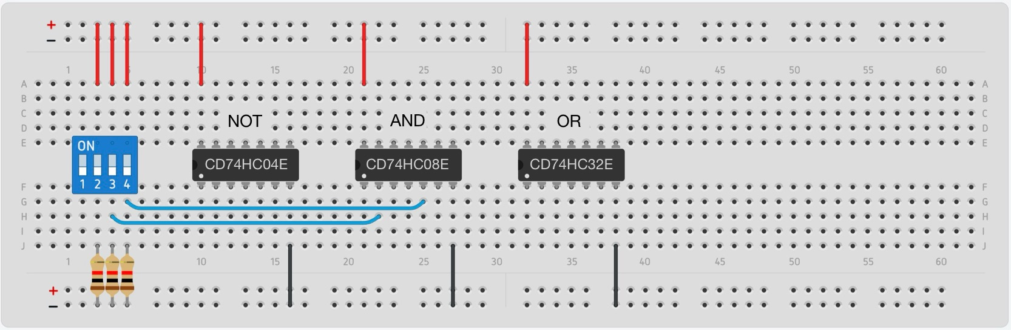

Figure 7: Connect the inputs $x_{1}$ and $x_{2}$ to the 7408 chip (AND).

Next, connect the select input ($s$) and its inverse ($\underline{s}$) to the AND chip:

* Connect switch 2 to pin 1 of the 7404 (NOT) chip.
* Connect pin 2 of the 7404 (NOT) chip to pin 1 of the 7408 (AND) chip.
* Connect pin 1 of the 7404 (NOT) chip to pin 4 of the 7408 (AND) chip.
* Compare your circuit with the one shown in Figure 8.

Verify that you connected the inputs to the 7408 (AND) and 7404 (NOT) chips correctly. Show your progress to the TA before you proceed.

## 

Figure 8: Negate the input $s$ using one of the NOT gates.

Connect $\underline{s}$ and $s$ to the corresponding AND gates.

## 

## 4.3 Finish the Circuit and Connect the Output to the LED

Connect the outputs of the two AND gates to an OR gate:

* Connect pin 3 of the 7408 (AND) chip to pin 1 of the 7432 (OR) chip.
* Connect pin 6 of the 7408 (AND) chip to pin 2 of the 7432 (OR) chip.
* Verify that your circuit is similar to the circuit in Figure 9.

## 

Figure 9: Connect the outputs of the two AND gates to an OR gate.

Use the LED to display the output of your circuit:

* Connect pin 3 of the 7432 (OR) chip to a 1 kΩ resistor.
* Connect the other end of the resistor to the anode of the LED (the longer end).
* Connect the cathode of the LED to ground.
* Your circuit should look similar to the diagram in Figure 10.

Do not turn on the power yet. Before proceeding, have the TA verify your final implementation.

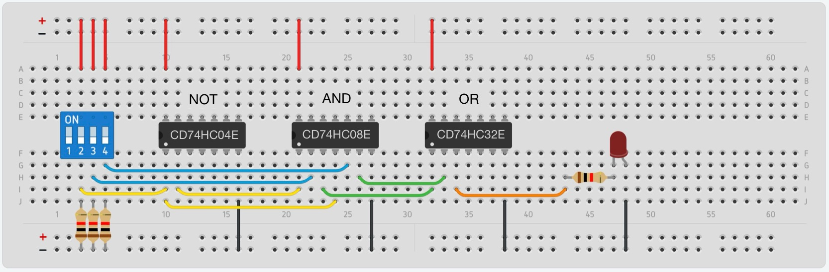

Figure 10: Visualize the output $f$ by connecting it to the LED.

# 

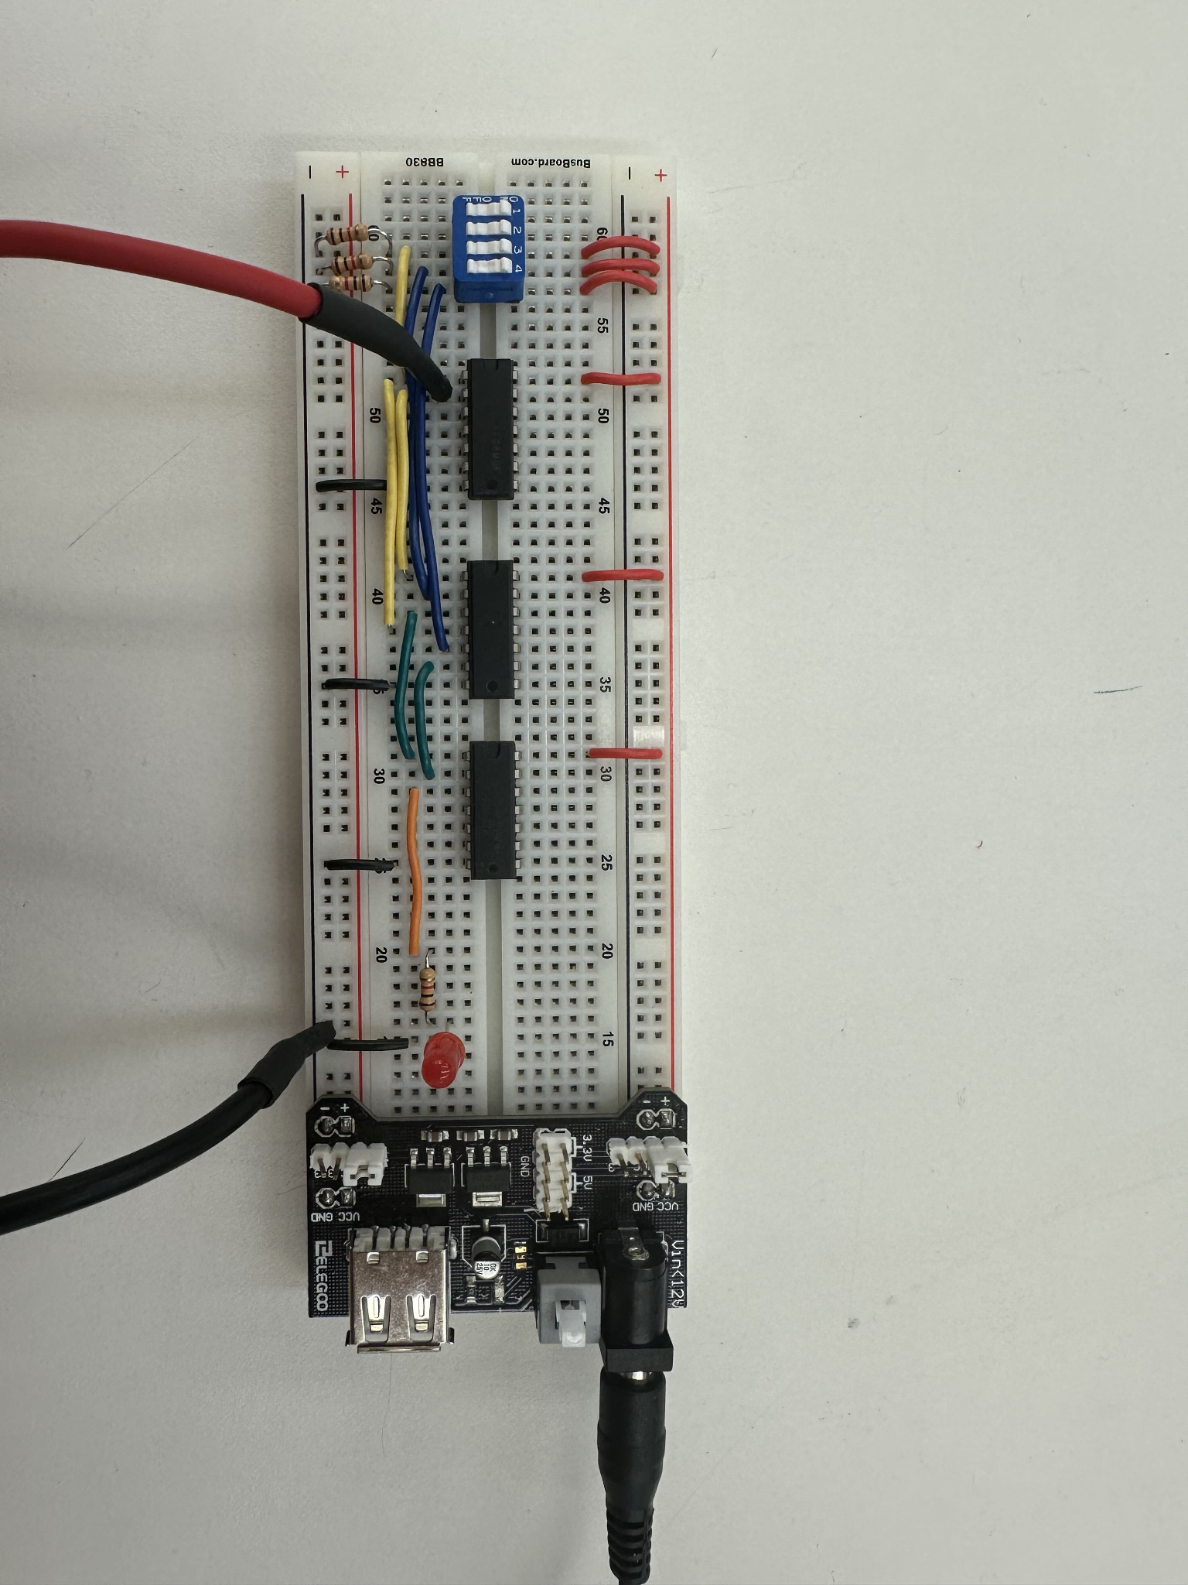

Figure 11: Completed breadboard implementation of a 2-to-1 MUX.

# 5.0 Testing

Test all rows of the truth table that you filled out in the prelab to verify that your circuit works correctly. If your output does not match the expected values, double check all connections to ensure that they are placed correctly and that they have not come loose during assembly.

Once you have the MUX completely tested and working, demonstrate your circuit to the TA.

Troubleshooting Tips: Trace all wires with the tip of your pen to confirm that they connect to the right columns of the breadboard. Verify that the LED is in the correct orientation. Carefully touch the chips to measure their temperature.If any of them feels hot, it may be burnt out and should be replaced.

# 6.0 Measure Voltages with a Multimeter

The LED shows only the final output of the circuit. To investigate the intermediate outputs of the logic gates you need to use a multimeter. Turn the circular dial in the center of the multimeter to the 20V marker. Connect the black lead of the multimeter to the ground rail on the bottom of the breadboard. Use the red lead to measure the voltage at a specific point. For example, Figure 11 shows how to measure the output of the NOT gate. After completing all tests, show the recorded results to the TA for a final check off.

## 6.1 Test One

Test the voltage on the select input. Insert the red lead of the multimeter between switch 2 and the resistor that is in the same column of the breadboard. Measure the voltage when the switch is off (first measurement) and when the switch is turned on (second measurement).

## 6.2 Test Two

Test the voltage on the output of an AND gate. Insert the red lead of the multimeter into the column connected to pin 3 of the 7408 (AND) chip. Measure the value of $\underline{s}x_{1}$ when the three inputs are $sx_{1}x_{2}$ = 010 (first measurement) and $sx_{1}x_{2}$ = 111 (second measurement).

## 6.3 Test Three

Test the voltage on the output of an OR gate. Insert the red lead of the multimeter into the column connected to pin 3 of the 7432 (OR) chip. Measure the voltage for inputs $sx_{1}x_{2}$ = 001 (first measurement) and $sx_{1}x_{2}$ = 011 (second measurement).